**Assignment: Design Thinking**

As stated in problem statement we come up with a following solution.

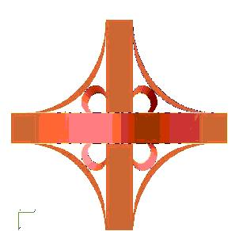

Considering the future and the problem of traffic, we propose that we should have at least one flyover on one of the two-perpendicular road. The plan of their interconnection is as shown in above diagram.

The above design plan not only reduces the cost, but it is also effective and rigid. It will save the cost spend on signal indicators. As we are not using the signal indicators in our plan which reduces the waiting time of vehicles and somewhat help’s to solves the traffic problems.

we are also building pedestrian way so that people can as use of that for walking and other related stuff. Considering the risks of accidents because of huge traffic, we are building the cross subway's so that people can do use of that for walking and small transportation.

We have done a special provision for the peoples with disabilities to come and go via subway's. The subway's will only be used by the walking people to easy out their daily stuff. We have done the separate provision of service lane for two-wheelers and for local vehicles in the plan.



The above image represents the demo or actual pictorial representation of plan